Basic Needs India

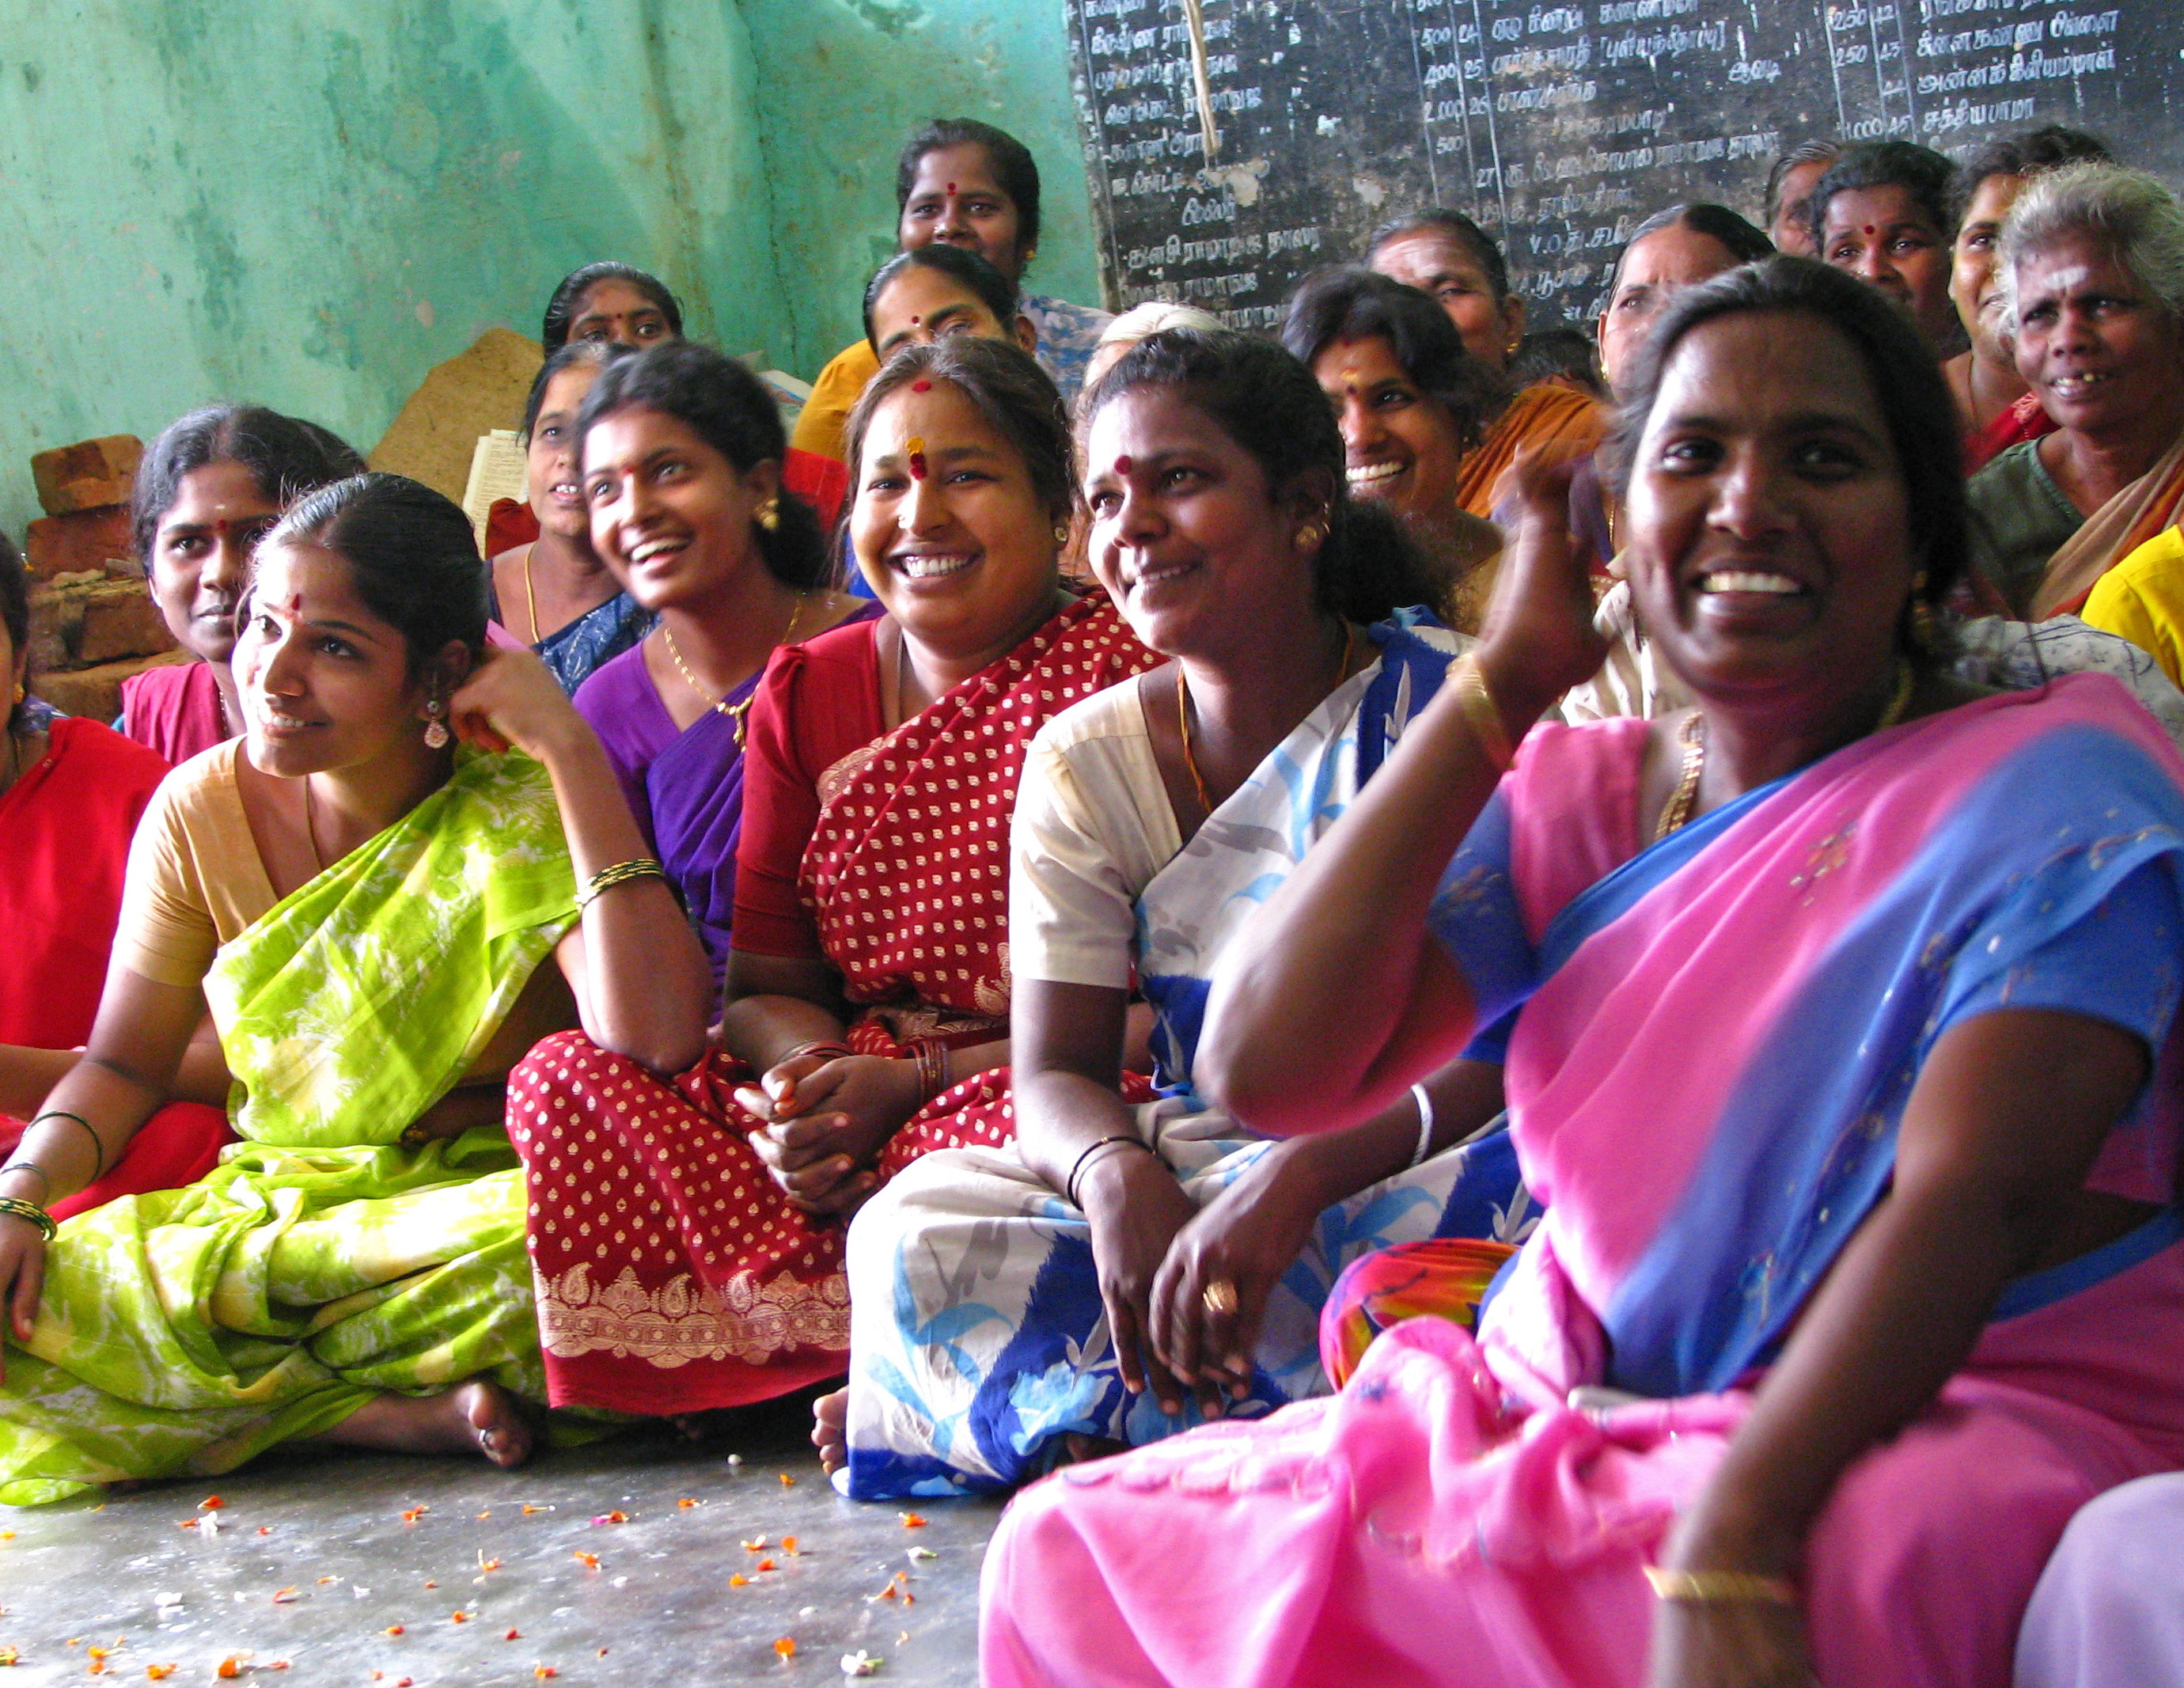

BNI
Promoting Mental health and Development
Annual Report 2014 -15

Introduction
Basic Needs India (BNI), since 2001, has worked on mental health issues across 50 districts in the states of Karnataka, Andhra Pradesh, Tamil Nadu, Kerala, Jharkhand, Bihar, Maharashtra and Odisha. In collaboration with partners, BNI has also reached out to people with mental illness living in 100 slums in Bangalore city. With nearly 15 years of experience in the community mental health and development initiative, BNI and partners have effectively demonstrated practices that benefit persons with mental illness and their families for their development and inclusion in the society.

Currently BNI is engaged with partners in Karnataka, Andhra Pradesh, Tamil Nadu, Maharashtra and Odisha. This report highlights the activities that were put into practice in these states during April 2014 to March 2015.

The thrust areas of our work during the year have been –
- promotion of Community Mental Health and Development (CMHD) programs in collaboration with partners in Odisha and Maharashtra;
- Promoting cadres at six sub-district clusters in Karnataka and Andhra through fellowship for ‘community engagement for mental health promotion’.
- Giving technical guidance and support to 14 NGOs located in one district each in Andhra Pradesh and Tamil Nadu to include persons with mental illness and issues of mental health in their CBR program.

Activities during April 2014 to March 2015
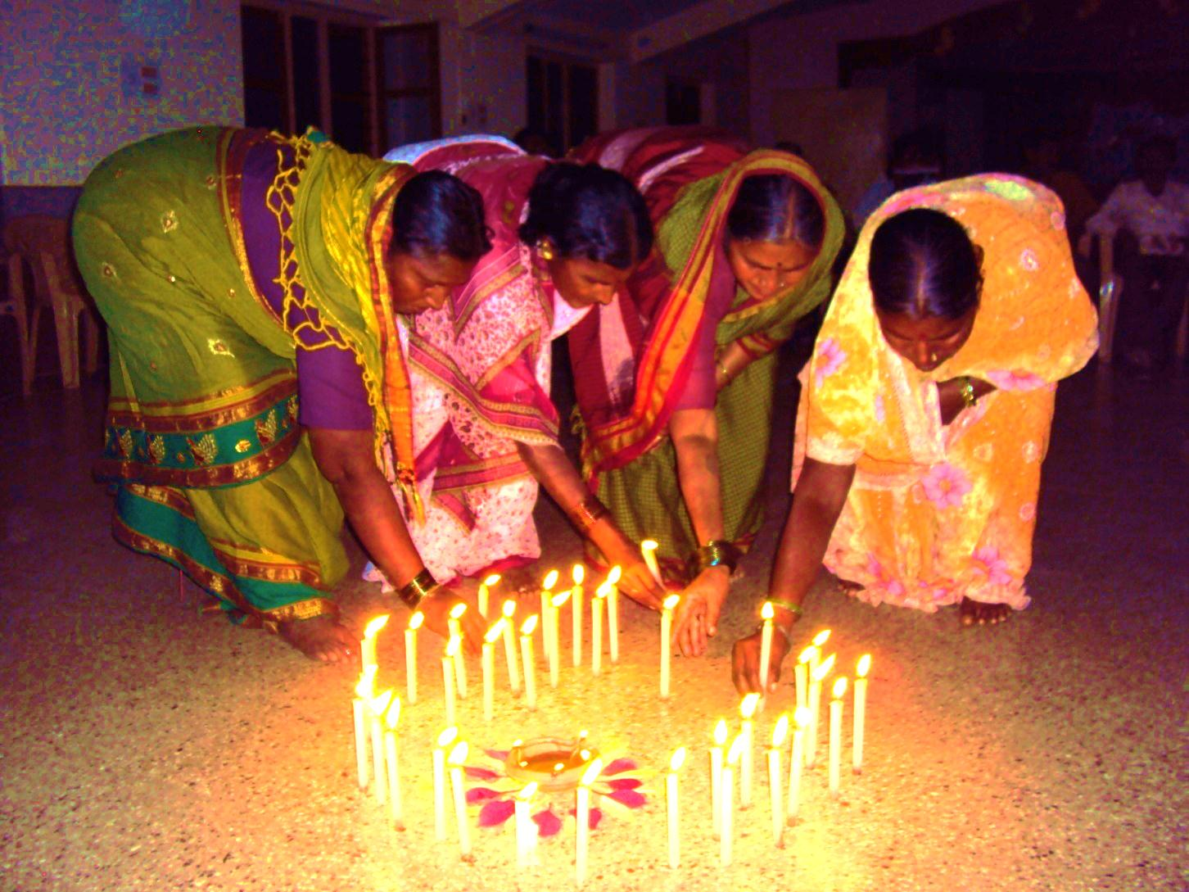

It was a demanding year for BNI to learn lessons on sustainability due to some financial constraints that allowed for deeper learning experiences of continuing the work on CMHD programme with partners in the states of Maharashtra and Odisha.

It was heartening to learn that the partners had sustained the work with persons with mental illness and their families with their own and from local initiatives, with minimal external financial support. BNI however continued to give the technical support for the programme.

Other highlights during the year include:

- `An impact evaluation of the Fellowship Program’ of three years was done.
- A handbook on community mental health by Dr Shyam Ashtekar for the grass-roots level workers was published.
- A new initiative of organizing a self-financed training on ‘psycho-social skills development’ for senior level workers was started.
- A tie up with two researchers from an Australian University to learn about the impact of the Community Mental Health and Development (CMHD) model was initiated. The outcome of the findings is awaited.

Community Mental Health
and Development (CMHD)

Under the CMHD model, the project aims to create a caring, accommodating and understanding environment to ensure service provision, social inclusion and livelihood opportunities for persons with mental illness and their families.

There are six partners in Odisha and five in Maharashtra (one partner has two projects) who actively implement the CMHD model. These partners have effectively included persons with mental illness and integrated the essential mental health aspects in their ongoing activities.

Renewed funding for the second phase in Orissa and Maharashtra was approved by SDTT in February 2014. During the earlier gap period, the partners sustained the program at a minimal level with their own resources. As a result of this experience, the partners have strongly expressed a need for building sustainable systems during this second phase. Their suggestions on ways to sustain PWMIs during the gap period have been included while planning this phase.

The emphasis during this phase was two folds – First, building sustainable systems by capacity building at different levels of stakeholders. Secondly, involvement of all stakeholders in the process of fulfilling the rehabilitative needs of PWMIs and family carers. Appropriate activities were initiated to meet these two aspects.

In Odisha 675 PWMIs from phase one and 216 new ones were identified and supported for their rehabilitation. In Maharashtra there were 1,571 re-identifications and 232 new identifications made and support initiated. Programmes in both states are progressing well.

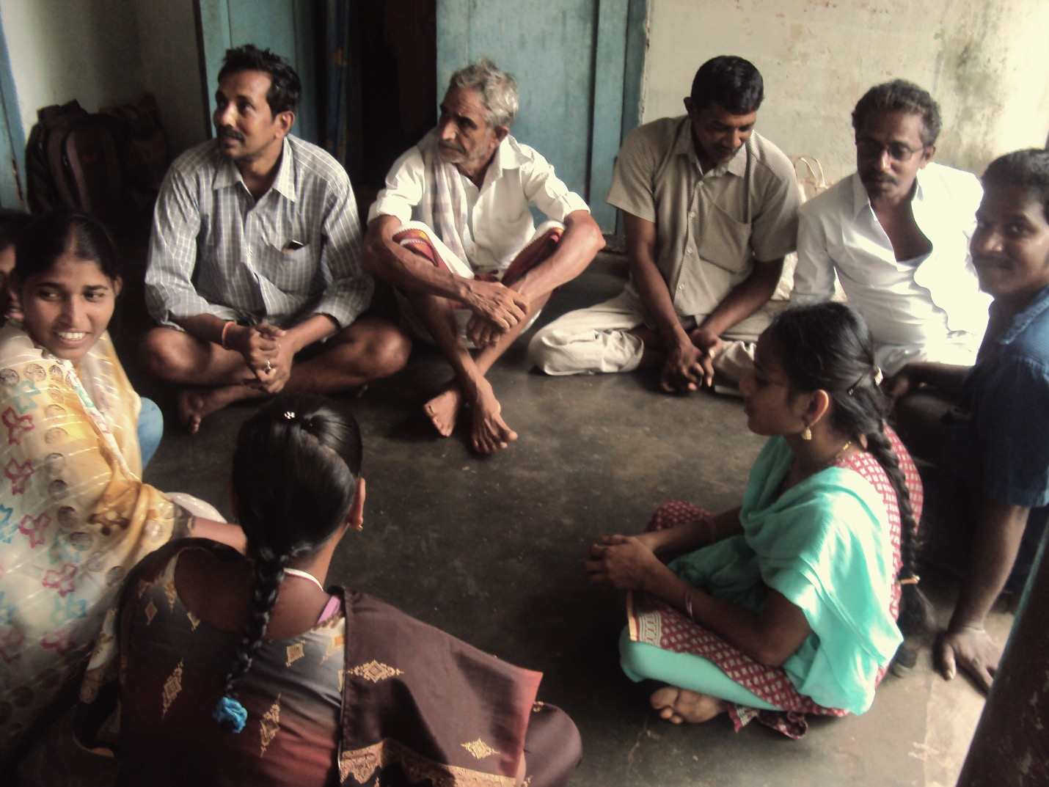

Some of the main points and focus were on
- Recruiting and training the required personnel by BNI and partners
- Enhancing the ownership by partners through a ‘consortium’ forum in each state
- Holding orientations and capacity building workshops for different levels of personnel of the partner groups.
- Each partner identified an area with around 50,000 people as an intensively involved area.
- Preliminary steps towards identifying of community volunteers.

BNI, with the support of ‘senior mentors’ conducted two sets of capacity building training for the partner staff and identified resource persons for training the volunteer. ‘Training of Trainers (TOT)’ programs of these resource persons were conducted to do their work effectively.

The identification, selection and recruitment of volunteers (up to 10 per partner) in the involved areas of all the partners have been completed. The TOTs have successfully fulfilled the basic training on mental illness and mental health for the volunteers in their respective regions.

At the partner level, the following activities were conducted - community awareness meetings; facilitating medical camps; support for livelihood to selected families; orientations on CMHD to local government personnel; advocacy initiatives with local authorities and initiation of family support groups (FSG) in one Panchayat per partner. All these have resulted in significant outcomes with the affected population.

The publicly provided psychiatric services and medications (one of the minimum essential support for PWMIs) were available in less than 50% of BNI’s partner districts. In the remaining districts these services were received through private providers. This issue is being taken up with the authorities concerned for rectification.
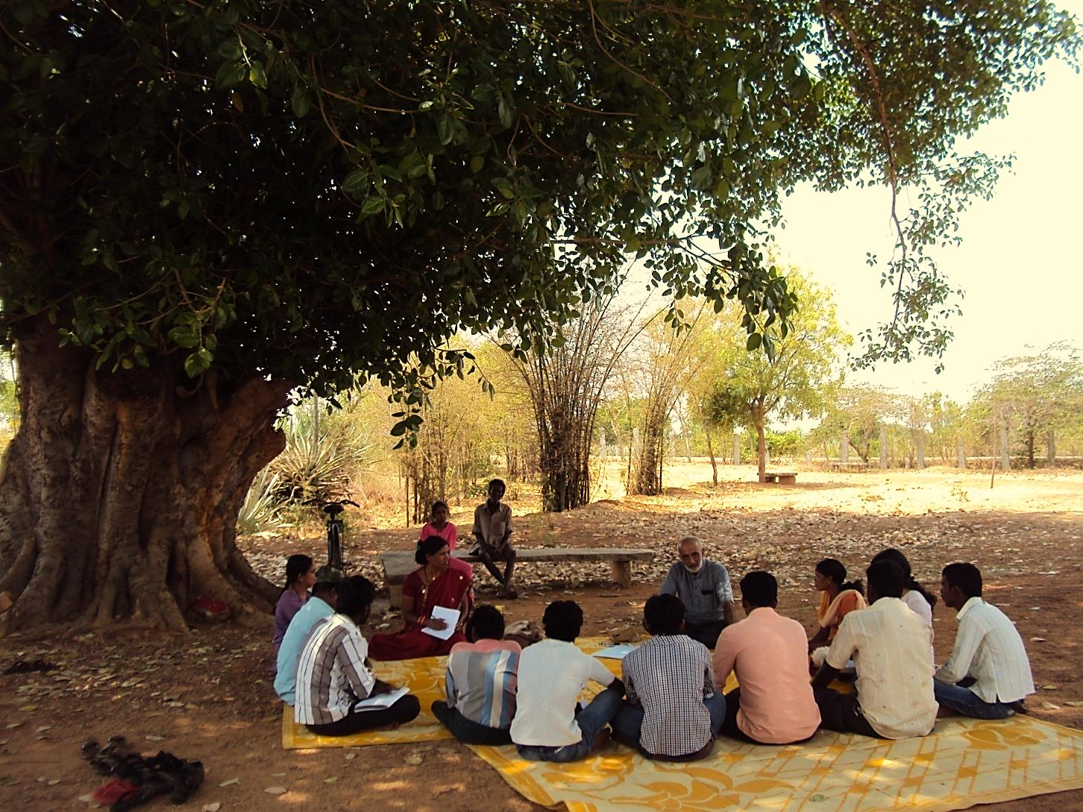
Training of volunteers on mental illnesses and related issues

Fellowship Programme

The third batch of Fellowship Program supported by Leaders’ Quest Foundation UK was implemented effectively at six clusters - five in Karnataka and one in a neighboring district of Andhra Pradesh. This batch had 30 Fellows and 11 Mentors from partners, most them were of people’s organizations. These partners dealt with the issues of marginalization of communities including the disabled, dalits, women, children, domestic workers, tribal groups etc.

The program aimed to incorporate promotion of mental health into partners’ work in the community. Five residential training modules were conducted with six-months of ‘Project Implementation’ undertaken by the Fellows, each Fellow taking up a project of his/her own choice. The Core Team at BNI, in addition to giving training, visited the clusters to understand the progress. The heads of Partner organisations were brought together three times during this period to reflect and exchange views. A one-day exposure and learning about the program was also organized for members from other NGOs.

Impact Evaluation of Past Batches of Fellowship

A participatory Impact Evaluation of the previous two batches of the Fellowship Program was done. Led by an external resource person, the evaluation required the participants (from each partner) to visit all the 11 locations and participate in activities at each location. This resulted in a significant understanding of the outcomes, part of which is summarized in the table below. This is further detailed in the report of the evaluation.

GROWTH AT INDIVIDUAL ‘SELF’ LEVEL OF FELLOW | GROWTH AT FAMILY LEVEL | GROWTH AT GROUP LEVEL
Openness  Handling negative emotions  Confidence (efficacy)  Self Respect  Meaning and purpose  Socio-economic self reliance | Family’s acceptance of individual’s growth  Provision of space for initiatives – taking up challenges, higher responsibilities  Introduction of altruistic and gender equity values  Enhanced emotional coping  Enhanced socio-economic status  Enhanced social standing / respect | Understanding of own situation and barriers to change  Understanding of own resources to make changes  Enhanced resources of group and actions towards solutions  Growth in groups’ sense of efficacy.  Strengthened solidarity.

With the completion of third year phase of Fellowship Program in January 2014, some follow up activities were carried out in this period. The Fellows, Mentors and partner representatives were brought together at the cluster level for a one day reflection on the occasion of the Naidu Memorial event. The Fellowship Experience Certificates were given to all those who had completed the program. The partners, fellows and mentors expressed the need for continued capacity building support and linkage. These follow up events were creatively linked with other activities to ensure mutual value addition.

Training and Technical Support to Partners of CBR Forum

BNI is giving technical support to capacitate the staff of six partners in East Godavari district in Andhra Pradesh and eight partners in Tiruvallur district in Tamil Nadu to include persons with mental illness in their CBR programme. Additionally, since October 2014, a mental health program has started at Gulbarga in Karnataka with the involvement of six partners. Field workers of BNI visit each partner for two-days twice a year; and provide one classroom training to the staff of all partners together.

The two-day field visits to each partner by BNI member involves
- Visiting families of PwMI with the field staff to assist them with family visit skills;
- Meeting DPOs to support them to advocate for PWMI’s entitlements and to raise awareness on PWMI and carer support needs and integration into DPOs;
- Review meetings of the partners to monitor quantitative outputs, discuss the qualitative aspects i.e. strengths and limitations of their work (observed in the partner field visits) and facilitate corrective steps.

The classroom input includes experiential skill building in psychosocial skills and skills required for guiding the field staff in their work and for advocacy.

Since the program in Tiruvallur district is new, the partners (except IRCDS who has past experience in CMHD) are in the early stage of identification with an average of 10 to 15 PwMIs per partner. The workers of these partners require and appreciate the field visits very much as the support given is helping them to learn directly through interaction with PwMIs.

In February 2014, BNI together with ADD India team, facilitated the staff and leaders of the Vasantham Federation (formed by IRCDS) in their engagement with District Administration for the entitlements of PwMIs. This required preparing the partner staff to collect the required data (on those denied entitlements), planning for a day’s meeting called by District Administration with all department officials, giving orientation to the assembled group of government officials on the issues, needs and rights of the PWMIs.

The credibility of IRCDS and Vasantham federation with the District Administration and the skilled support of ADD team ensured that the effort was successful. The District collector appreciated the efforts of the Federation and NGOs for the exhaustive data on Disability and persons with mental illness and assured action on their memorandum.

As an outcome of BNI technical support to the partners in East Godavary,
- The partners have improved CMHD skills and follow up to PwMIs has improved;
- DPOs have been strengthened and Mandal level DPOs have been formed;
- Community stakeholders like PRI members and local government service providers are getting involved in PWMI’s issues;
- Community awareness on mental illness has been initiated. All the partners have initiated village level DPO”s with an average of 10 - 15 members. They have been active in their engagement with district administration for facilitating PWMI entitlements.

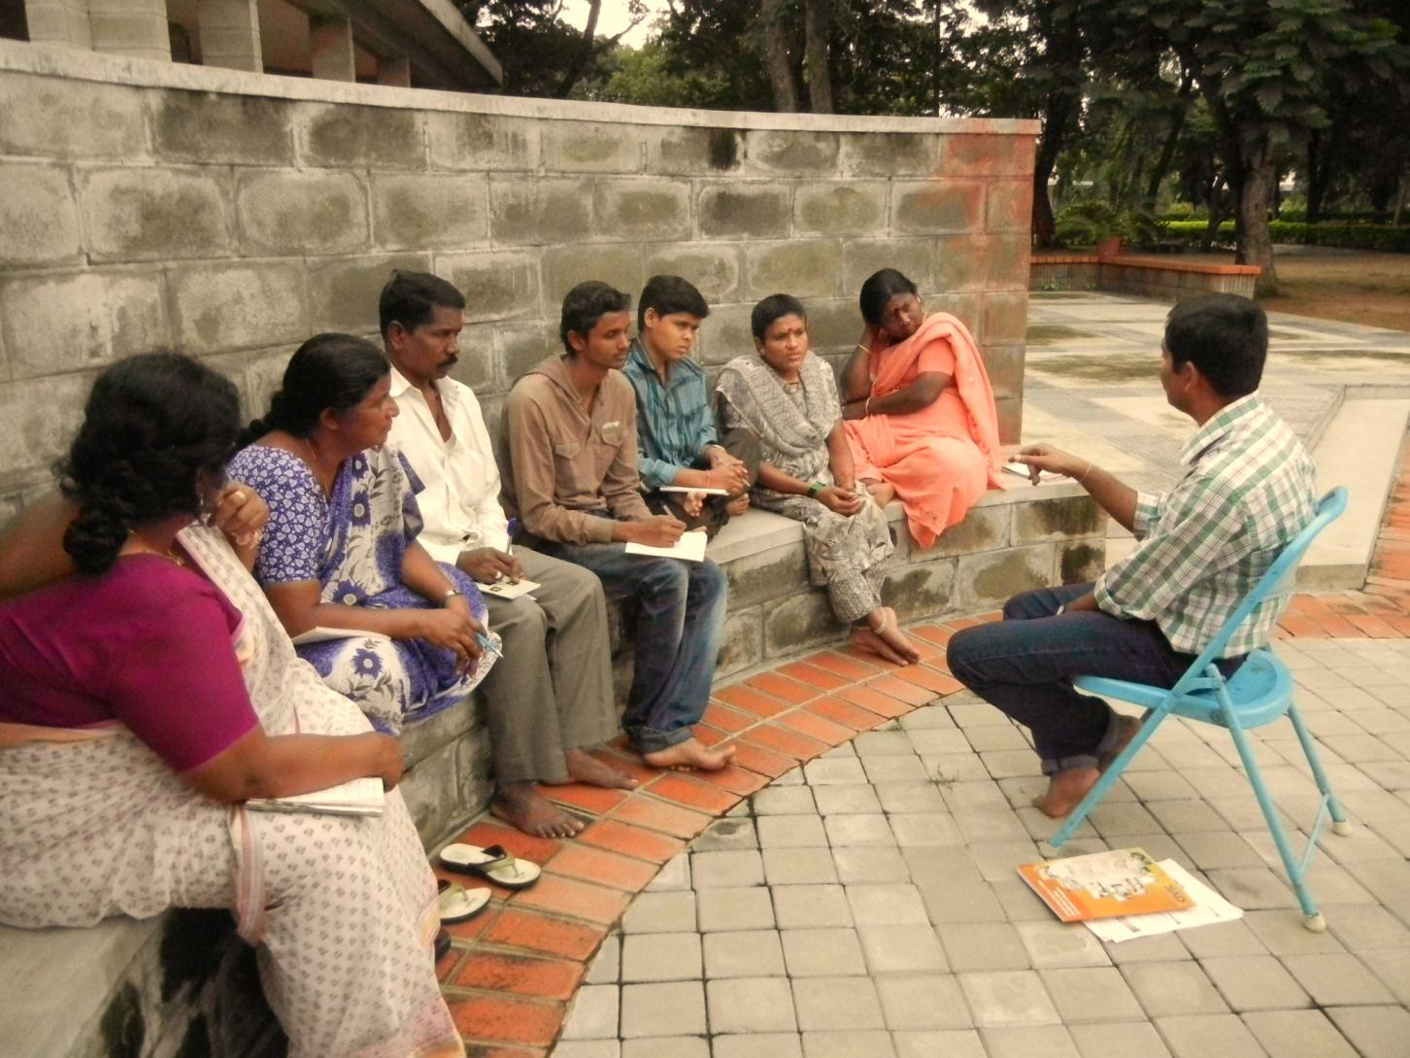

*************************

A QUALITATIVE RESEARCH STUDY ‘AN EXPLORATION OF
THE PERSPECTIVES OF KEY STAKEHOLDERS’
A qualitative study was explored by two senior Researchers from an Australian University focusing on the perspectives of various stakeholders on each component of the CMHD program in practice. Sample for the study included pioneers, Trustees and staff of Basic Needs India, fellows and mentors involved in BNI’s Fellowship Program, stakeholders from partner organizations and carers/family members and persons with mental illness who have received support from Basic Needs India or their partner organizations. In the first stage, 12 participants including pioneers, Trustees and staff members of BNI were invited for extensive interviews. Later seven focus group discussions were held with fellows/ mentors, local federation members and carers/persons with mental illness from three partner locations. It is expected that useful feedback about implementation of this approach could hold recommendations for practical improvements.

TRAINING ON ‘PSYCHO-SOCIAL SKILLS DEVELOPMENT’
BNI conducted two training courses of four-days each on psycho-social skill development which was financed by the participants themselves. It was conducted by a senior mental health Professional, who is also a BNI trustee. Fourteen participants underwent this training. The training was participatory, experiential and was built on the rich experience of the trainer. The participants gained through reflecting on beliefs about ‘self’ and through the skills learnt in ‘Helping Skills’.

HOSTING SOCIAL WORK STUDENTS OF TATA INSTITUTE, MUMBAI
BNI and partners hosted four 2nd year social work students from the Tata Institute of Social Science for a month to give them an exposure to ‘community mental health’. Before preparing the field partners, a detailed introductory program was conducted for the students and their local guides, after which a four weeks placement was worked out. The participants gained experience by staying in the basic local conditions and by being exposed to the various CMHD activities. The TISS faculty informed that the format developed for this posting was useful in systematizing a field-posting program for the students.

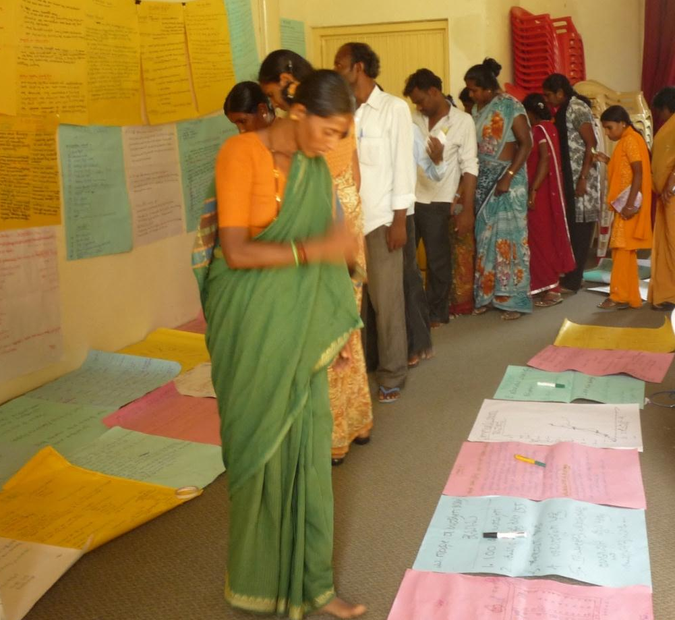

Handbook
DEVELOPING A HANDBOOK FOR GRASSROOTS MENTAL HEALTH WORKERS
BNI sourced a small grant to engage a person skilled in developing grass roots health workers educational materials to develop educational material from BNI’s community experiences. The consultant visited various locations of the partner programs in Maharashtra, interacted with different grassroots stakeholder groups and interviewed partner staff for insights in the training material development. He also consulted other professional resources in mental health to compile a comprehensible and well-illustrated document for grass-root workers. The handbook gives community level strategies and guidelines for the management of common mental illnesses. This handbook is in English and Marati and we hope to publish this in other regional languages to benefit a wider range of grass-root level health and mental health workers.

Other Contributions of BNI
As a member of the Karnataka Mental Health Task Force, BNI contributed to the development of the Recommendations from the sub-committee on community mental health. The Task Force promoted Day Care Centres in every district and ‘Super Tuesday Clinics’ (monthly psychiatric clinics with availability of psychiatric medications) at all taluka hospitals by the Karnataka State Government.
- A research study ‘Gender Perceptions of Families and Communities in community mental health and development programs’ based on earlier research was published in this period.
- The 1st Naidu Memorial Event was held on 17th April with a public audience and had talks by mental health professionals.
- A senior staff of BNI was deputed for a year’s ‘flexi time senior fellowship – in community health’ with SOCHARA, the resource group on health. The in service Fellowship benefited the staff through the knowledge gained particularly in the areas of critical understanding of the public health system and developments in the People’s Health Movement.

MFC Annual Meet on Mental Health HEALTH
PUNE, FEBRUARY 2015
BNI participated actively in the MFC Annual Meet since this year’s theme was relevant to BNI’s work. The team took part in the preparatory meeting at Hyderabad and ensured the participation of several partner staff and BNI team members who were involved in Maharashtra and Orissa programmes. BNI made a presentation on the CMHD experiences, during when a recovered PwMI from a local partner shared personal experiences of recovery, which proved to be a valuable learning for the participants.

(An article about BNI’s 15 years of CMHD experiences was compiled and it was published in the MFC Bullettin 365-366, March–October 2015.)

Conclusion
Over the 12 -13 years of experience in the community mental health field, BNI and partners have improved in their ‘resource
support’ capacities. The resources we see are:
- The grass roots level models:
  - CMHD programs at various stages of development and spread across partners area of work in 50 districts of eight states.
  - In the four Southern states, the progression of CMHD beyond the NGO partner role to ownership by the DPO group (carers, stabilized individuals and local supporters).
  - The experience, learning and linkages of partner NGOs, the DPOs and federations promoted by them of successfully engaging with the public provisioning system at the local level.
- The learning of the CMHD programs at the ground level have been consolidated into training manual and are being field tested for senior professionals.
- Experiential trainings on ‘psycho-social skills building’ found to be valued by trainees and hence being self financed
- Awareness materials arising from BNI’s experience of working in the field.

BNI and partners are poised to play a larger role in the national mental health scenario, especially in making heard the voices of the poor mentally ill persons, their carers and supporters at the grassroots level and the local solutions they have developed.

About BNI and its management:

Vision: Basic Needs India seeks to satisfy the essential needs of persons with mental illness in India and to ensure that their basic rights are respected and fulfilled.

Mission: Initiate programmes in India which actively involve persons with mental illness and their carers and enable them to satisfy their basic needs and their basic rights respected. In so doing, stimulate supporting activities by other organisations and influence public opinion.

TRUSTEES (2014 – 15) Dr. S. Rajaram – Chairperson
Mr. R. Ramachandran – Secretary
Mr. N.Thyagaraju – Treasurer

Ms Sanghamitra Iyengar – Trustee
Ms. Vandana Bedi – Trustee
Ms. Mallika Rama Rao – Trustee

AUDITORS: Gowthama & Co
Chartered Accountants
23/57, 41st Cross, East End ‘C’ Main
Jayanagar 9th Block,
Bangalore – 560 069
Ph: 080-26636042 / 26656194

BANKERS: State Bank of India
Banaswadi Branch, Bangalore 560 043

FCRA Registration No: 094421170 dated 23.06.2005
(Renewed)

BNI is registered under 12AA of Income tax Act and also has exemption under Section 80G of Income tax Act.

Thanks to the partners in Odisha, Maharashtra and the southern states for their cooperation and support in our programmes. Thanks also to many persons with mental illness and their families for their understanding and cooperation.
Thanks to Anagha Smrithi, a student, for designing this report.

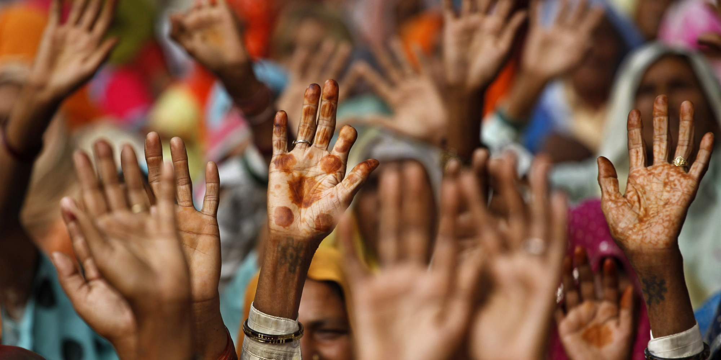

Thanks and gratitude to all the supporters and
well wishers of our work.

Thanks and appreciation to
Misereor, Germany
Sir Dorabji Tata Trust, Mumbai
Leaders Quest Foundation, UK
Spark Capital Advisors Pvt. Ltd, Chennai
And many Individuals
For contribution to the work of BNI

Basic Needs India
4005, 19th Cross (Off K.R. Road)
Banashankari 2nd stage, Bangalore 560 070
Tel: 080.2676 5855 Email: bni@basicneedsindia.org
Website: basicneedsindia.org

