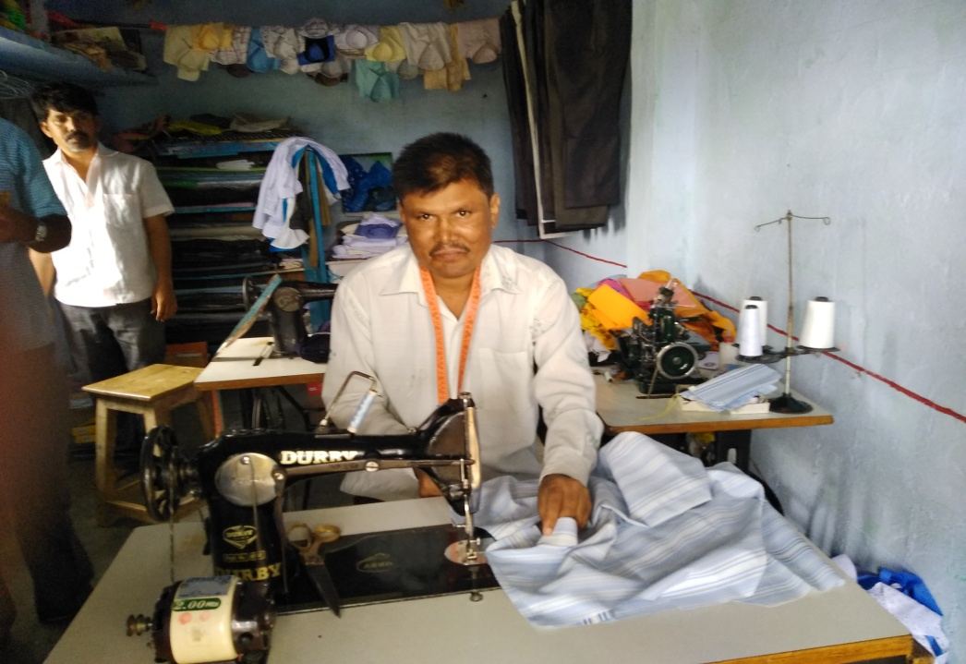

Annual Report 2017 -18

Basic Needs India
4005, 19th cross, (Off K R Road)
Banashankari 2nd stage
Bangalore 560 070
Ph: 080. 2676 5855
Email: bni@basicneedsindia.org
Website: www.basicneedsindia.org

Basic Needs India

Reg. Under Indian Trust Act, No. 642 – IV 2000-01
Date of Registration: 22nd March 2001

TRUSTEES (2016 – 17) Ms. Mallika Rama Rao – Chairperson
Mr. R. Ramachandran – Secretary
Mr. N.Thyagaraju – Treasurer
Ms. Vandana Bedi – Trustee
Dr. Shirdi Prasad Tekur - Trustee

AUDITORS: Gowthama & Co
Chartered Accountants
23/57, 41st Cross, East End ‘C’ Main
Jayanagar 9th Block,
Bangalore – 560 069
Ph: 080-26636042 / 26656194

BANKERS: State Bank of India
Banaswadi Branch, Bangalore 560 043

FCRA Registration No: 094421170 dated 23.06.2005
(Renewed up to October 31, 2021)

Vision: Essential needs of persons with mental illness in India are fulfilled and their basic rights are respected”

Mission: Initiate programmes in India which actively involve persons with mental illness and their carers and enable them to satisfy their basic needs and their basic rights respected. In so doing, stimulate supporting activities by other organisations and influence public opinion.

BNI’s role is that of a resource organization that works with partner agencies to implement programs to create a caring, accommodating and understanding environment to ensure service provision, social inclusion, livelihood options and the right to equal opportunities for persons with mental illness and their families.

Photo on the cover: Gundappa, a recovered PWMI from Malgatti village, Gulbarga district, doing tailoring earning Rs.650 (approx) per day.

It was an intense year with activities to complete the programmes as per the schedule. The work with partners in Odisha, Maharashtra and two States in south India – Karnataka and Tamil Nadu progressed satisfactorily as per the plan. The programme in Odisha and Maharashtra was revised due to the fact that financial support from SDTT was only till February 2018, hence the focus was on ways of continuation and sustainability of activities after the end of grant period.
Findings from the mid-term review of the programmes in Maharashtra and Odisha done earlier helped in understanding the impact of the work done so far and also the limitations and challenges faced in the programme. Steps were taken to overcome the shortcomings and for further involvement of the community members, families and care givers to ensure sustainability of the programme after the withdrawal of active involvement by BNI in these programmes. Much emphasis was given on capacity building of carers and local volunteers to support the programmes.
The video film titled “Breaking Barriers” with English sub-titles in 20 minutes duration and the handbook for the workers were circulated among the partners. The film presents the issues and challenges faced by persons with mental illness and their families in Odisha and Maharashtra, and the efforts made by the workers and partners to shift from individual centric approach to a larger community based participatory approach in dealing in mental health issues.
The Mental Health Care Act provides persons with mental illness their share of dues and establishes their rights. The provisions by the government for their well being should bring them out of their disadvantaged situation. The issues affecting persons with mental illness are complex and require combined effort from families and communities to work with the Government authorities and system to overcome them. BNI will continue to support and strive with perseverance for this cause.
Activities during 2017 - 18
The programs in all the regions progressed satisfactorily during the year. The support from Sir Dorabji Tata Trust (SDTT), Misereor, Germany and CBR Forum/Caritas India helped greatly in continuing our work with persons with mental illness and families. The details of work done are described below, which focussed mainly on engaging, supporting and building the capacity of workers of partners to continue the work in a sustainable way.
Programmes in South India
BNI was engaged with eight partners in Tiruvallur district in Tamil Nadu; and five in Gulbarga district in Karnataka. These partners are supported by CBR Forum. BNI is engaged in promotion of mental health and inclusion of persons with mental illness in their programmes and activities.
The programmes at Thiruvallur and Gulbarga are at different levels. In Tiruvallur, the strategy adopted in rehabilitating persons with mental illness is very positive. The staff have gained knowledge on mental illness and understand mental health issues well. They are building the skills of village level DPOs in identification, referral for treatment and follow-up, inclusion of PwMI in DPOs, and in advocating for their entitlements. They are regular in home visits, building rapport with families and good at supporting in medical rehabilitation of persons with mental illness. A camp for reintegration of persons with mental illness in families was organised and the response from family members was very positive.
At Gulbarga, working with five partners, persons with mental illness have been identified, and referred for treatment and being followed-up. Training has been given to form care givers group and they are in the process of being formed. Meanwhile some PwMIs have been included in the local DPOs. Here too a camp for reintegration of persons with mental illness in families was organised and the response from family members was very positive. Overall, the partner staffs are putting efforts in strengthening their skills with a holistic approach.
Areas focused and support given during the field visits
- Knowledge of partner staff on psycho social areas
- Communication and interaction skills
- Facilitation, planning and organizing skills
- Inclusion of PwMI and family members in DPOs and other support groups
- Team work
- Knowledge on entitlements and enabling PwMI and families in accessing the same
- Networking with officials and panchayat representatives
The staff of partners have built good rapport with PwMI, families, Community leaders, local panchayath, health officials and other support groups in the community. Persons with mental illness are involved in livelihood activities and in 100 days in MGNREG work.

The mental health work in the two regions is proceeding according to the plan. Attention is also given towards in-depth sensitization on mental health issues, the role of DPOs and building staff skills toward facilitating this process and strengthening caregivers forums.
Besides working with the partners of CBR Forum, training was also given to the workers of PRAJWALA in Hyderabad, an organisation working with children of sex workers. The training was on psychosocial issues.
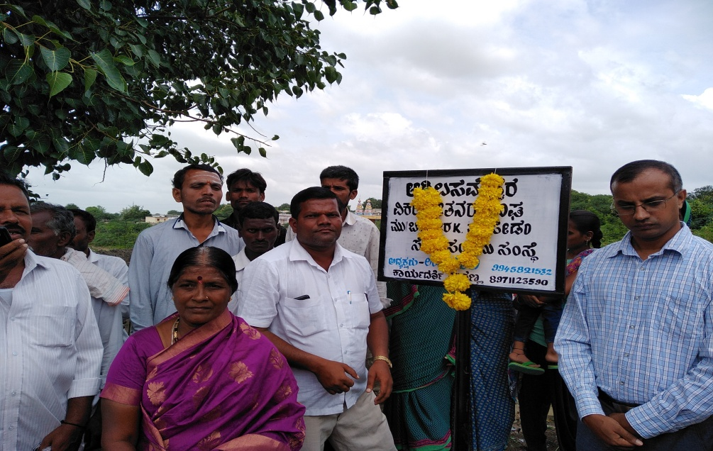
Inaugural of DPO name board at Bettagere village at Sedam taluk in Gulbarga district
Programmes in Odisha and Maharashtra
The programmes with six partners in Odisha and four partners in Maharashtra continued with much vigour and enthusiasm. Being in the final stage of completion of the current phase, partners in both states looked at ways of continuing the programme with emphasis on some aspects for eg., increasing the community involvement and ownership to ensure that persons with mental illness and families are included in the various programmes undertaken in the community.
To objective of the programme in the two states was to ensure that 5,500 PWMIs are accessing comprehensive care including psycho social, medical and community level follow up.
Indicator - Identification, referral for treatment and home visit follow-up, provided to the targeted numbers of PWMIs (in the 5.5 lakh population of partner involvement in the 2 states.
- Total PwMI identified – 5053
- Total PwMI referred for treatment – 4446
- 2,480 PwMI on regular treatment and stabilized.
- 3,867 PwMI were followed up regularly
- Psycho education to all the identified families through home visits by volunteers and field staff
- 260 PwMI are involved in vocational training and income generation activities
- Around 900 PwMI have accessed social entitlements
- No. of Family support groups promoted 53
The data above shows that the project was able to achieve almost 90% of the set target.
Efficiency, effectiveness and relevance: The affected community members were also mobilised for greater ownership of their concerns, an important objective of this ‘withdrawal phase’. This relates to three critical interventions: - capacity building of community volunteers to be resources in mental health – Developing intensive interventions in one ‘pilot panchayat per partner, focussing on ownership of the affected groups – Initiating mobilization of the affected groups towards being able to engage with the governance structures and push the government system towards greater accountability and transparency.
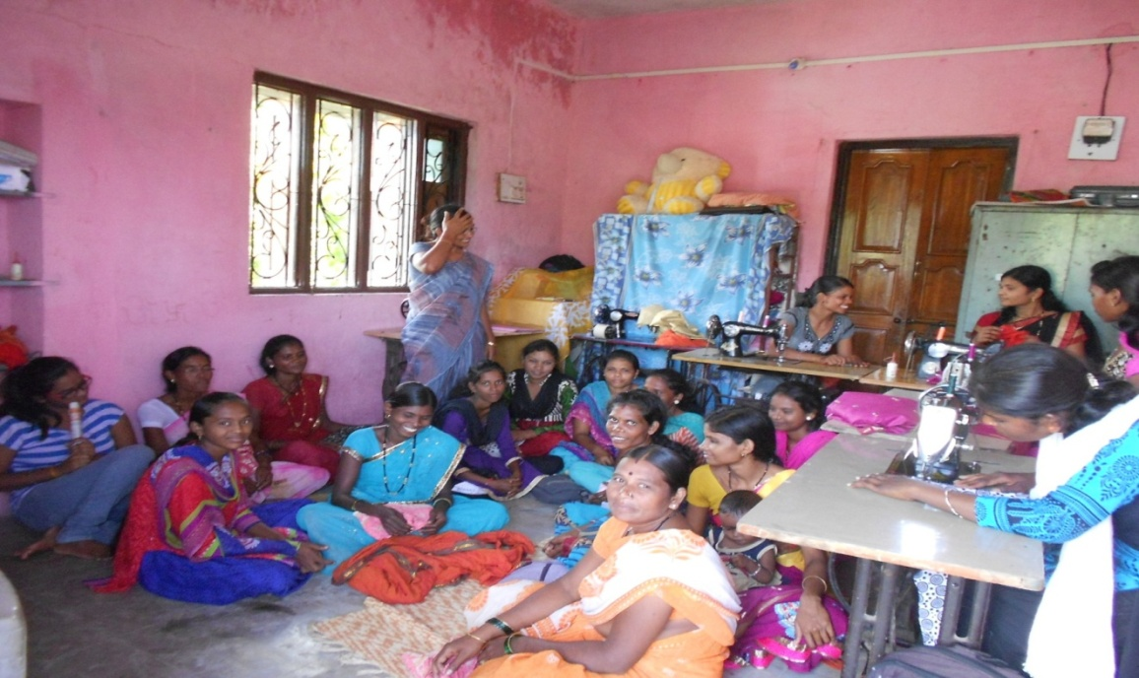
Persons with mental illness and carers in training and for social gathering
Management and Finances in BNI during the year
BNI had eight staff members during the year.
Dr. S. Rajaram Executive Director
Guru Raghavendra Associate Director
Madhusudhan Prog Coordinator for South India
Rajeeb Karmi Prog Coordinator for Odisha
Ganesh Mandekar Prog Coordinator for Maharashtra (left in Sept)
R. Ramachandran Finances and Communication
Firdaus Easa Admin and Finance Officer
Sujatha Training officer (part time)

Persons with experience and knowledge on mental health issues were taken as Associates and as Resource persons to guide in development of the programme. Thanks to Vikram Kenere of JSVS for supporting the work in Maharashtra.

Finances during the year were adequate for the programmes in Odisha and Maharashtra. As the SDTT grant ended in February, the gap in financial support increased. 84% was received as grant from donors and the balance 16% from donations, bank interest and from own efforts.

The main donors were Sir Dorabji Tata Trust (SDTT) and Misereor, Germany for the programme in Odisha and Maharashtra; CBR Forum / Caritas India for the capacity building of mental health workers in south India.

Thanks and gratitude to Spark Capital Advisors Pvt Ltd, Chennai for their generous contribution as CSR support to our work. Donations were also received from individuals and other supporters.

The organization managed the finances judiciously during the year. The excess of expenditure over income is large. Serious efforts are needed to raise fund for programmes and also for management of the organization. The website of the organization is updated with details about the organization and to help in fundraising.

Acknowledgement and appreciation
BNI expresses its deep gratitude to all those who have contributed to sustain our work which has helped thousands of families to improve their quality of life. Our sincere thanks to Misereor, Germany; Sir Dorabji Tata Trust; CBR Forum/ Caritas and ADD India for the support received. Special thanks to Dr Nina Urwantzof of Misereor Germany for her unflinching support for our work.
Thanks to Ms Valli Seshan and Vandana Bedi for their valuable guidance and support to our programme. Thanks are also expressed to mental health professionals, Advisors, Associates and resource persons who have supported and guided our work with much enthusiasm.
We also express our thanks and appreciation to M/s Gowthama & Co, the auditor for auditing our accounts and dealing with the statutory requirements.
Thanks to the Trustees of BNI, who guided and supported the work of the organisation in difficult times and in taking decisions and to guide the work towards the purpose of the organisation.
Thanks to our staff for their involvement; partner NGOs and most importantly, persons with mental illness and their families for their active participation in programmes and for sharing their experiences. Thanking everyone.
R. Ramachandran Secretary – Basic Needs India.

