Pursuance Paves Way
EARLY CONDITION
Bishi, a 19-year-old girl lives in a small village of Boudh District. She stays with her father, mother, sister and three brothers. In 2017, she passed her 10th class and her mental health problems appeared after her schooling in 2018. She behaved in an unusual way with multiple emotional expressions. She started doing harmful things to her family and roaming in the nearby villages without informing her family members, she was not having food, talking to herself, spent nights of sleeplessness etc. It was a big shock to her family. They could not accept the fact that she was mentally ill.

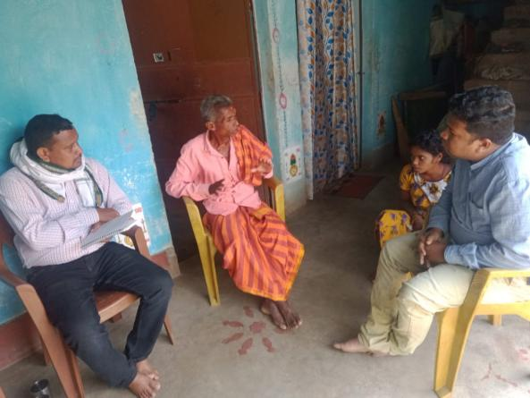
They took her to a doctor at Tadameru and started medical treatment. After six months of medication there was no change in her behavior. Her father turned towards faith healing. After that they consulted the Ayurveda Doctor at Sonepur District. Then one of the Puruna Cuttack CHC Doctors suggested that they take her to Burla (Sambalpur) Medical College. During that period the Pandemic (Covid-19) started, so her treatment also stopped. They turned to Black magic, Ayurveda medicines, and Herbal treatment for years but there were no changes.

TEAM INTERVENTION
After four years in 2022, during community awareness in the village, the team came to know about her illness. Subsequently, the team visited her family several times, interacted to understand about the history, symptoms and treatment. After number of home visits and interactions, her father agreed to go in for treatment, yet again. Later she was taken to Dhalapur CHC. In this process, AWW, ASHA and the community volunteer supported the CMHD team. Treatment continued and gradually she became stable after medication.

PRESENT CONDITION
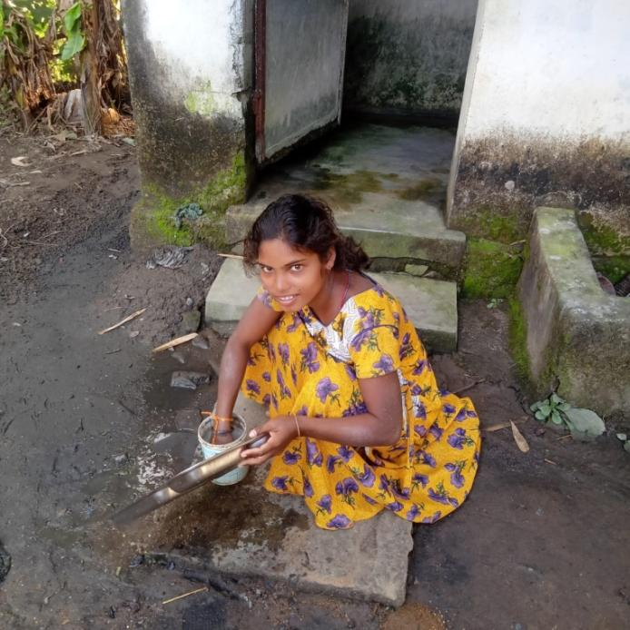
Today, her symptoms have decreased. The team visits the family regularly to ensure treatment compliance – they observe the progress and provide psycho-education to the family members. The team educated the family about the process of her reintegration.

Her family is very supportive and takes care of her. They treat her with love and affection. Even for the community, it is good motivating case to enable them to have a positive attitude towards MI and PWMI. During the WMHD observation in the Block, her father was invited as a guest and honoured on the stage for his care and timely treatment and efforts to bring her to the mainstream. The team supported the family to get a disability certificate. Now efforts are being made to get disability pension.

