Long Road to Recovery
EARLY CONDITION
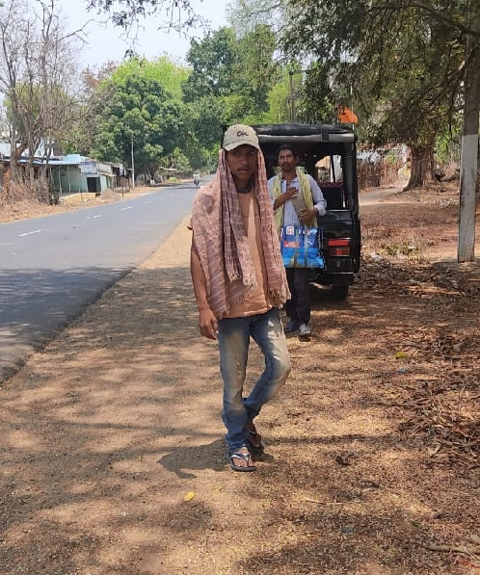
Sahu is a 22-year-old young man. His family comprises of 4 members, his mother and two brothers. They belong to the BPL category. His two brothers are daily wage earners and also engage in agriculture activity. When Ganesh was studying in College, he got addicted to smoking and drinking along with friends. Therefore, his study took a back seat and his interest in studies decreased.
BEFORE
He became silent and used to spend most of his time in solitude – he would not speak to anyone and started talking to himself. His addiction to alcohol increased tremendously. His brother took him to Sambalpur Government Hospital and he took medicines for 4 years – only then did his symptoms decrease and he improved. Following this, he stopped treatment resulting in relapse and he resumed the consumption of alcohol.
Before starting treatment
TEAM INTERVENTION
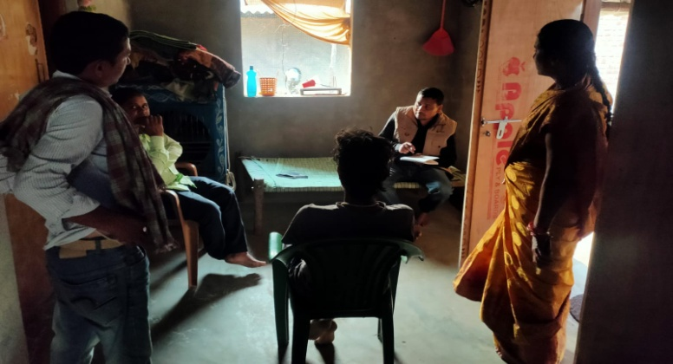
He was identified as a Person with mental illness in April 2022. The staff interacted with Sahu - his symptoms included sleeplessness, inability to do his daily work on time, aggressive behaviour, wandering, wearing dirty clothes and addiction to drugs. As he was aggressive, he often attacked family members. It was challenging to control him. Hence family members did not want to take the risk of including him in the family and taking him for treatment.
Team’s psycho-education to the family
NOW
After repeated visits by the community volunteer and interaction with the family for a few months, the family agreed to start treatment again. His treatment started at the Government hospital, Subarnapur. But his addiction was another challenge. With the doctor’s reference, family members decided to keep him in a Rehabilitation Centre for five months. The CMHD team supported the family throughout the process. The team visited Sahu at the Rehab Centre thrice during his stay there. After the course of five months, he stopped consuming alcohol completely and was taking medicines regularly.
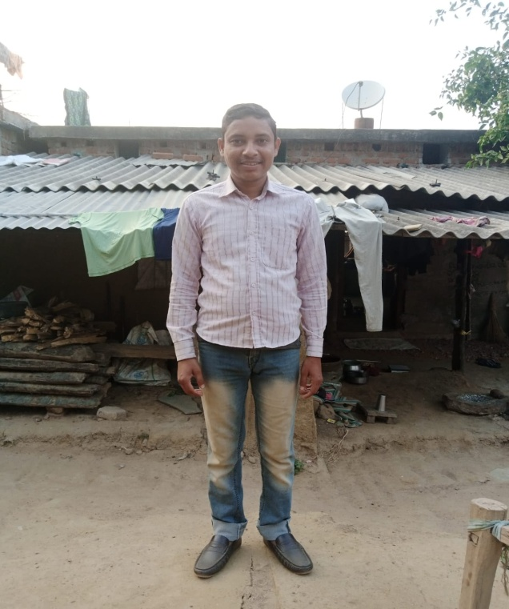

During the BNI SMHC visit, family was advised to involve him in house-hold activities. Now, he performs small household chores and consumes medicines as prescribed by the psychiatrist. His symptoms have almost vanished. The team also visits his home to observe further progress and support the family to reintegrate Sahu.
On the road to recovery

